**Brilliant labs:**

Brilliant Labs is an Atlantic Canadian-based charity. It is a hands-on, experiential learning platform empowering youth to learn through the integration of creativity, innovation and today’s technology with the United Nations Sustainable Development Goals (SDGs) and an entrepreneurial spirit in classrooms and communities.

Brilliant labs works on project-based learning, the platform contain multiple section in the form of blogs and provides various skills such as cyber-security, bio making, robotics, coding etc.

**"As far as learning is concerned, children are taught on this platform by giving them challenges. Once a relevant course or skill is taught, challenges are given based on that course or skill which the children have to complete."**

The design of this site primarily uses shades of purple( [800080](https://www.computerhope.com/cgi-bin/htmlcolor.pl?c=800080)) and magenta [(FF00FF](https://www.computerhope.com/cgi-bin/htmlcolor.pl?c=FF00FF)).

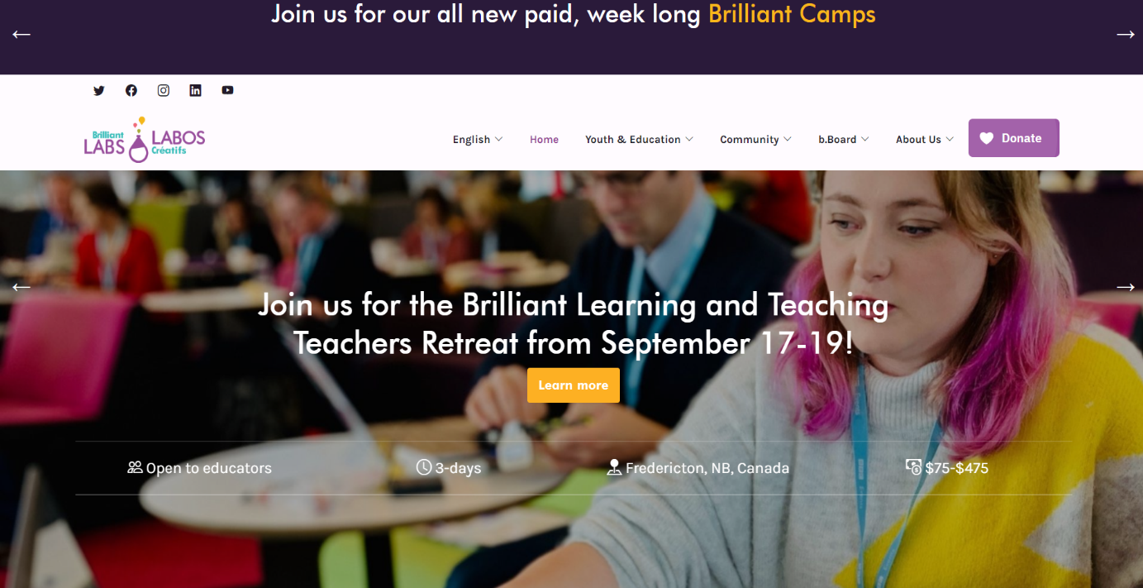

**Scratch JR:**

Scratch Jr is a user-friendly platform that teaches coding to young children (ages 5-7). It uses visual blocks in different colors that kids can snap together to create animations and interactions for characters, which are called "sprites." With these blocks, kids can make their sprites move, dance, and even talk. They can also design their own mini-stories and games, like digital puppet shows, where they control what happens next.

This platform is all about having fun while learning. Kids can experiment with the blocks, see how they work, and immediately see the results. It's like solving puzzles or creating their own adventures. Scratch Jr also helps develop important skills. Kids learn how to solve problems step by step, think in logical ways, and use their imagination to come up with cool ideas.

Plus, Scratch Jr lets kids share their creations with friends and family. It's like showing off their cool artwork or a story they wrote. This early introduction to coding and creativity lays a strong foundation for understanding computers and technology as they grow up.

**Scratch :**

Scratch promotes computational thinking and problem solving skills; creative teaching and learning; self-expression and collaboration; and equity in computing.

Scratch is designed especially for ages 8 to 16, but is used by people of all ages.The working of Scrach platform is as similar as Scratch Jr. **The Best thing about Scratch is, It is available in almost 70 languages so the accessibility of this platform increased.**

**Blocky:**

"Blockly" is a web-based visual programming language developed by Google. It is designed to teach beginners, particularly kids, the fundamentals of coding and programming through a simple drag-and-drop interface. Blockly uses a block-based approach where users snap together visual blocks to create code, allowing them to create programs without needing to write traditional code syntax.

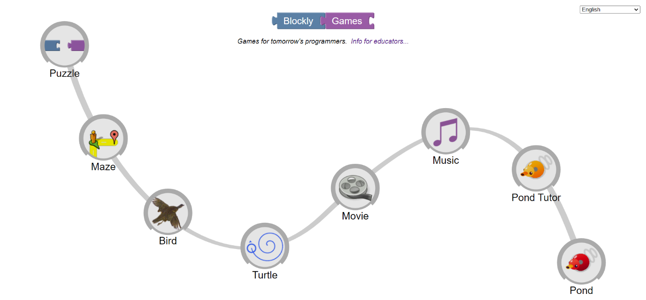

Key features of Blockly include:

1. Visual Interface: Blockly provides a user-friendly interface where users can manipulate and connect blocks to build programs. Each block represents a specific programming command or action.

2. Modular Blocks: Blockly's blocks are designed to fit together like puzzle pieces. This structure helps users understand the logical flow of programming concepts.

3. Block Categories: Blocks are organized into categories based on their functions, such as loops, conditionals, math operations, and more. This makes it easier for users to find the blocks they need.

4.Drag-and-Drop: Users can drag blocks from the toolbox and snap them together to create sequences of actions. This intuitive process allows beginners to experiment and learn programming concepts without worrying about syntax errors.

6. Educational Use: Blockly is often used as a teaching tool in educational settings to introduce programming concepts to students of all ages, including children. It helps build a strong foundation in computational thinking.

**Alice:**

Alice is an innovative block-based programming environment that makes it easy to create animations, build interactive narratives, or program simple games in 3D. Unlike many of the puzzle-based coding applications Alice motivates learning through creative exploration. Alice is designed to teach logical and computational thinking skills, fundamental principles of programming and to be a first exposure to object-oriented programming. The Alice Project provides supplemental tools and materials for teaching using Alice across a spectrum of ages and subject matter with proven benefits in engaging and retaining diverse and underserved groups in computer science education.

Alice provides the following features on their platform -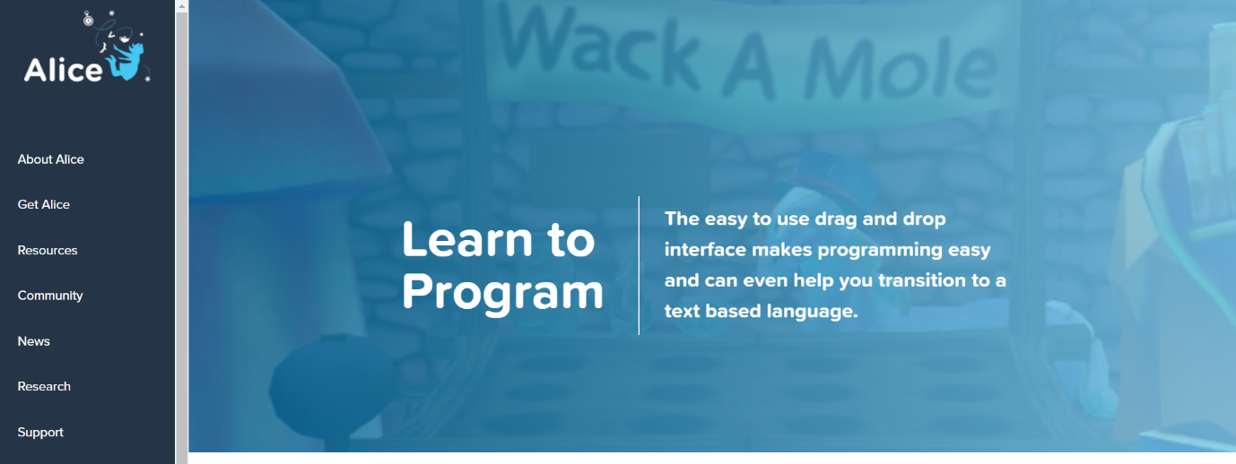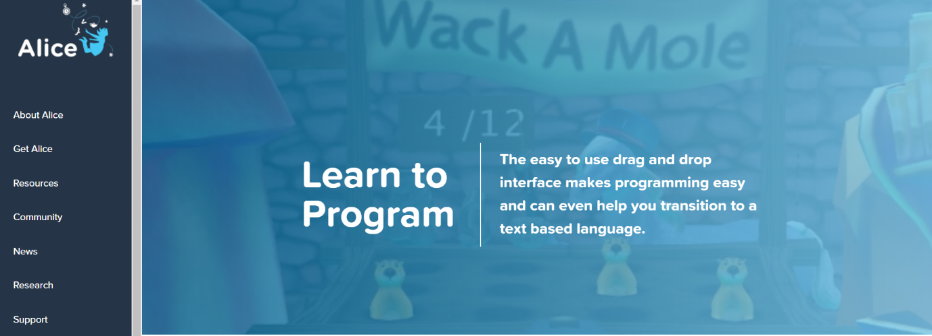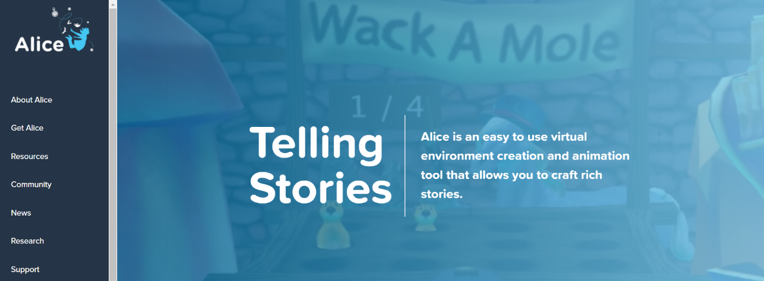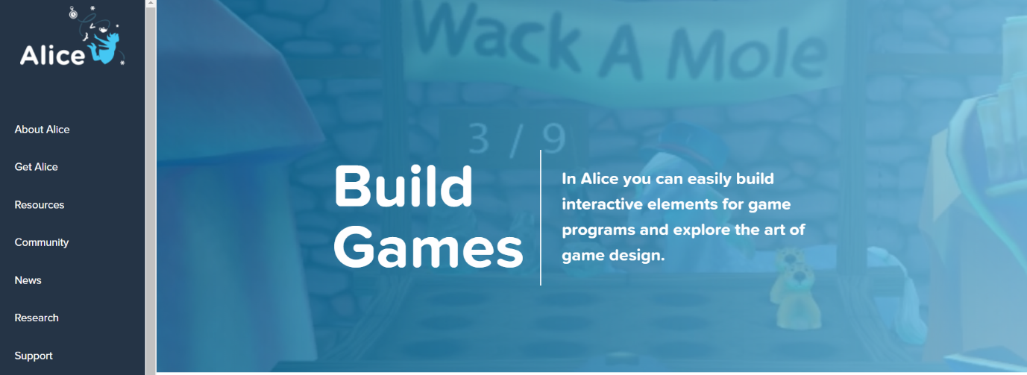

**MIT App Inventor:**

MIT App Inventor is a web-based visual programming platform developed by the Massachusetts Institute of Technology (MIT). It empowers individuals, especially those without prior programming experience, to create mobile applications for Android devices. The platform utilizes a block-based coding approach, enabling users to design and build apps by visually assembling blocks that represent different programming functions.

Features:

1. Visual Programming: App Inventor employs a visual, blocks-based programming language that eliminates the need for traditional coding syntax. Users drag and snap blocks together to create app functionality.

2. Component-Based Approach: Users design apps by selecting and configuring components from a palette, including buttons, text boxes, images, sensors, and more.

3. Media Integration: Users can incorporate images, sounds, and videos into their apps, enabling multimedia-rich experiences.

4. Data Storage: The platform supports data storage options, including local storage and cloud-based databases, allowing users to create apps that save and retrieve data.

5. Tutorials and Learning Resources: App Inventor provides a range of tutorials, sample projects, and learning resources to help users get started and build their app-making skills.

6. Community and Sharing: Users can share their apps with the App Inventor community, collaborate on projects, and remix existing apps to create new ones.